Dokcer : ---

____________________________________________________________________________

Virtualization: ----

Virtualization means run multiple Operating systems (OS) on single physical machine..

In virtualization every single VM machine is independent..

To setup VM hypervisor is required

Every VM has different credentials

for running an application you need a VM

if we setup multiple VM's for an application then we need multiple isolation VM's

space is wasted and high cost..

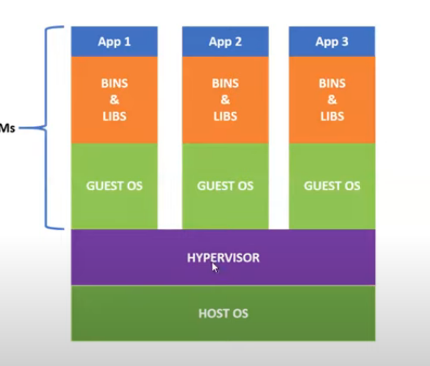

Containerization:--

Containerization is a thin virtualization, here containers means VM's..

containers has only one application

it will take the required files from host os.. containers has no OS.

it will use the kneral of hosts OS.

it does not have any OS

fast performance

self sustained

it has already architecture

all advantages of virtualization..

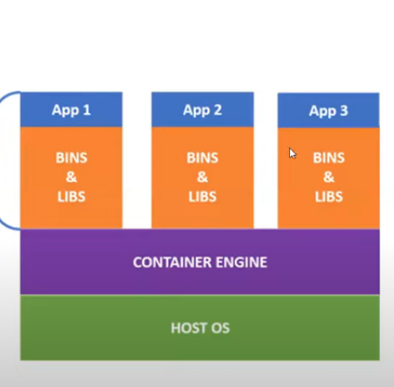

Container VS virtualization:

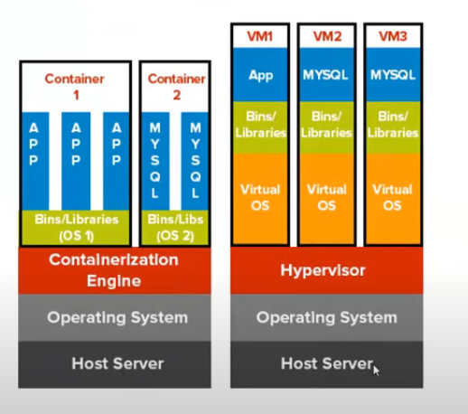

Docker is containerization platform that packages your application and all its dependencies together in the form of a docker container to ensure that your application works seamlessly in any environment..

Docker is a software platform that allows you to build, test, and deploy applications quickly.

Docker packages software into standardized units called containers that have everything the software needs to run including libraries, system tools, code, and runtime.

Using Docker, you can quickly deploy and scale applications into any environment and know your code will run.

Docker container: it is standardized unit which can be created on the fly to deploy a perticular application or environment..

it could be an ubuntu or cent os container...

Docker image: A docker image is a file.. comprised of multiple layers, used to execute code in a Docker container..

A image is essentially built from the instructions for a complete and executable version of an application..

Docker hub:---

It is a cloud based repository in which docker users and partners create , test , store and distribute docker images..

docker pull and docker push...

